CS3350 Assignment 4 Due: Sunday, 10/27 11:59 p.m.
This assignment is designed to deepen your understanding and practical skills in implementing hash tables and managing collision resolutions.
Instructions:
You will find an 'assignment4.cpp' file provided. Start by creating an empty C++ project, and then add 'assignment4.cpp' as the source file. There's no need to create additional files.
The project comprises two critical parts:
- Implementing a HashTable Class with separate Chaining:
- Develop a class, 'HashTable', that incorporates separate chaining. Complete the essential functions within this class: 'insertElement()', 'removeElement()', and 'printAll()'. A recommended approach is to employ an Abstract Data Type (ADT) “list” for the hash table's construction. It is advisable to use the 'list' ADT available in the standard library. For guidance on using 'list' methods, refer to the documentation available at: https://www.cplusplus.com/reference/list/list/
Focus on understanding the C++ examples for these specific methods: 'constructor', 'begin()/end()', 'erase()', and 'push_back()'.
- If the 'list' ADT does not suit your preferences, you have the freedom to comment out the provided segments of the 'HashTable' class code and proceed with your unique implementation.

- Creating a HashTable2 Class with Double Hashing:
- Develop another class, 'HashTable2', that incorporates double hashing. Complete the essential functions within this class: 'insertElement()', 'removeElement()', and 'printAll()'.
- For hashing functions, use 'key % total_elements' as the first hash function and '7 - (key % 7)' as the second.

Important Reminders:
- You are NOT allowed to change any code within the 'main ()' function.
- You are permitted to alter the code in 'assignment4.cpp', except for 'main()'. The objective is to ensure that 'main()' can successfully invoke functions from both 'HashTable' and 'HashTable2' classes, yielding an output identical to the provided sample below.
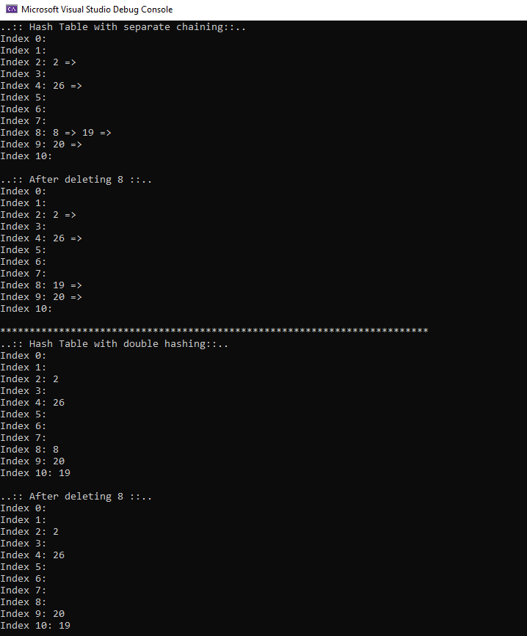

Submission
Submit a single assignment4. cpp to Canvas.

Grading Rubric

_______ (2) proper documentation/comments where appropriate.
______ (3) implementation of insertElement() in HashTable.
_______ (3) implementation of removeElement() in HashTable.
_______ (3) implementation of printAll() in HashTable.
______ (3) implementation of insertElement() in HashTable2.
_______ (3) implementation of removeElement() in HashTable2.
_______ (3) implementation of printAll() in HashTable2.

